**Business Station**

1. The header in the main search screen has non-required 3 mouse over clickable layers which are not required

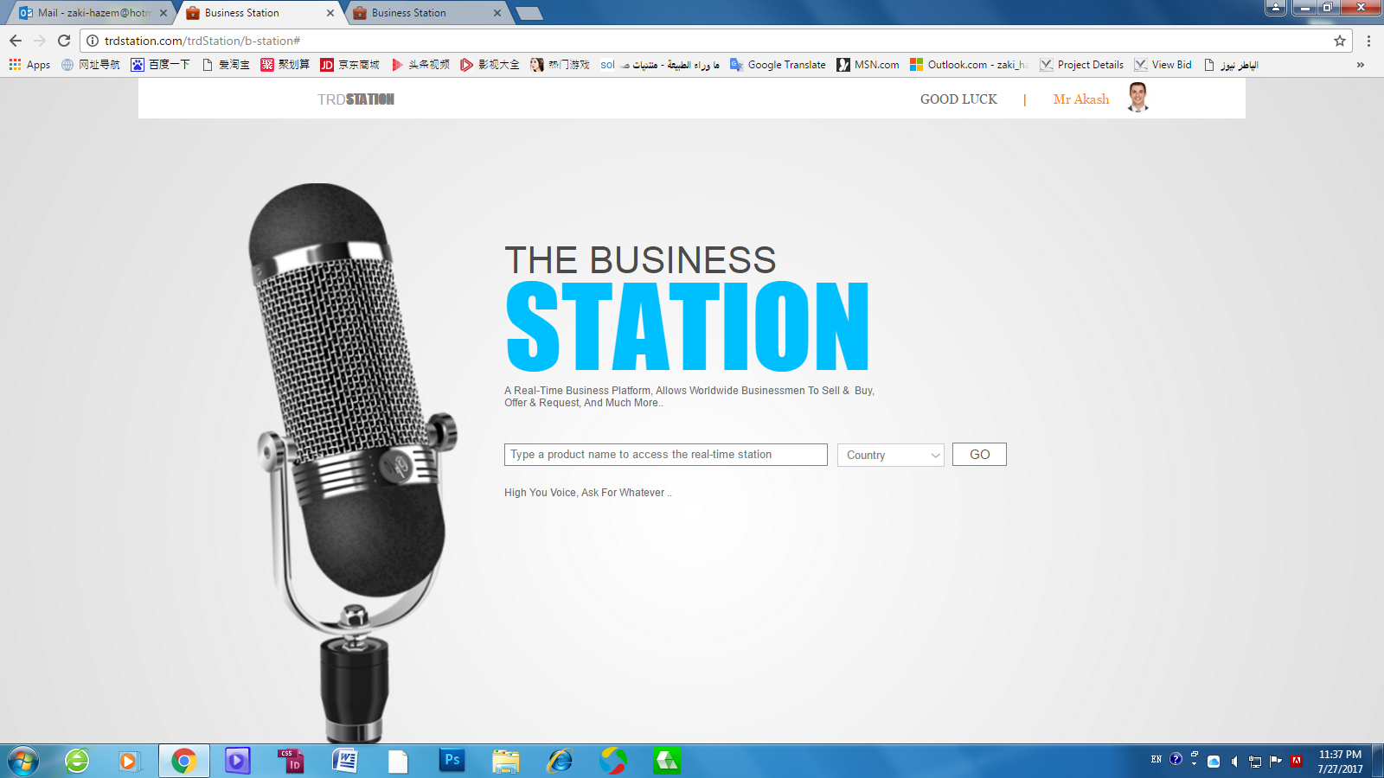

1. Please change the Initial value in the search box from ( please type product **name**…) to ( please type product **Keyword**…)
2. Please change the frame color of Country menu to match Search box frame + Go button.
3. Go button works without any words typed or country selected ( in my GUI this exist just to show you how it works because my GUI is static one), it should works as follows:
4. Type a product keyword.
5. select the country
6. In this case only go can works hide the intro screen and show the real-time B.Station screen.
7. 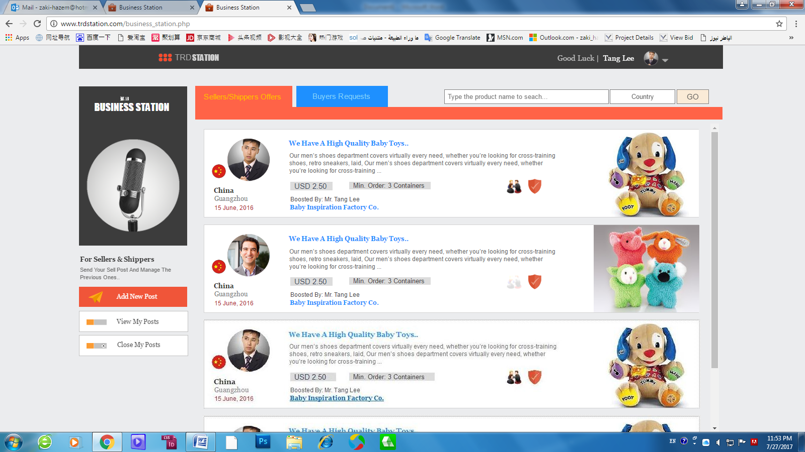The first intro screen should be shown one time only till the Business station page closed and opened next time..

**why we need the page and why it should hide till the tab opened again.?**

* The idea is we need to show result page full with posts and offers not empty.
* Because this page is a real-time request so we cannot open it for all products and all countries, this means a huge numbers of offers or requests will be displayed so fast and the member cannot control to follow or view any of them, that’s why we limit the search in one product and in one country as 2 kind of sorts.

**And regarding** why it will be hidden till member close it and open the page again, because during the posts ( offers & request) is going on in real-time, the member can search other product in the same country or other country, from the search bar in the Real-time screen ( second screen).



**Please note:**

* Please change the Initial value in the search box from ( please type product **name**…) to ( please type product **Keyword**…) in this screen also.
* Also in this search bar Member must type product keyword + select the country to search.
* Both tabs will display the same product real-time offers or requests, according to what member type.
* Real-time posts ( offers or requests) means all the posts send since 7 days till few second ago, by sellers or buyer.

Ex. suppose I am a Bags buyer in India, and send now a buying request including the word Bag, so all the sellers, shippers ( black horse) or buyers “”is I not block my post for buyers””, who search for the word Bags and select India as a country, can see my posts for 7 days till my post got expired and deleted.

* Also me can see the post I send by clicking on MY Posts, but I tried many time to send posts and search for it or even open my posts but No result.

1. in this under screen the profile image is not showing, although it showing on the first intro screen, please also move it little to up.

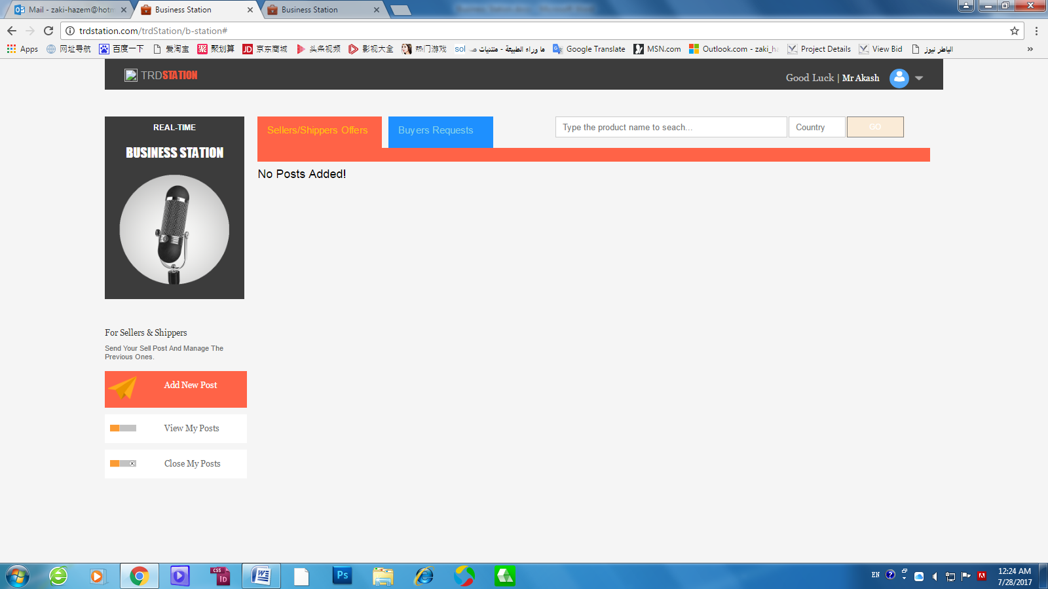

1. 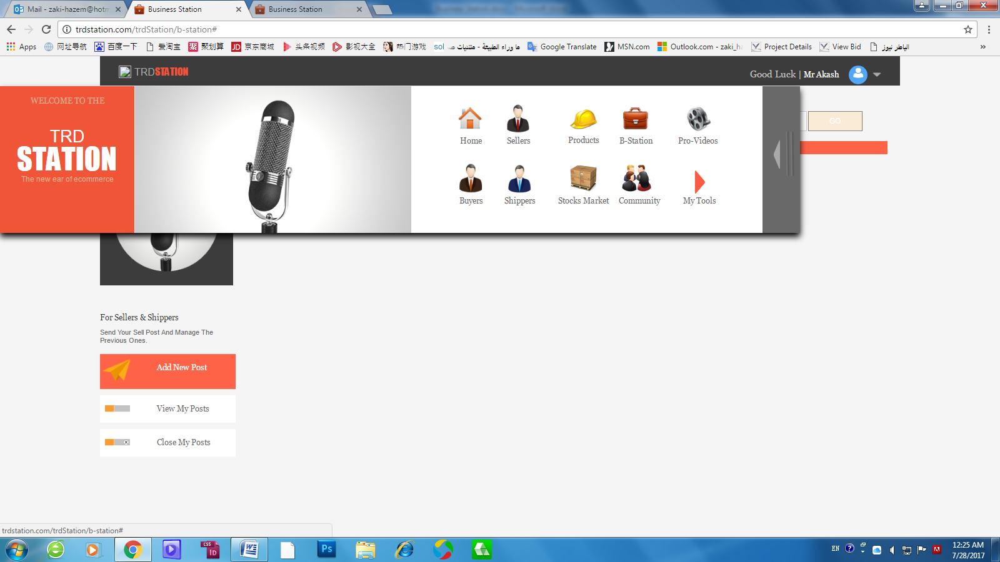The 6 dots menu icon not appear here and the menu is not in the center.
2. Please confirm the toolbox menu which in the home page.
3. **Add New Post:**
4. For sellers/shippers it’s a selling post works and active under the orange color tab, For buyers it’s a buying post works and active under the blue tab.
5. When click add new post by sellers the new post layer should appear and align the upper orange line ( to be in the center to going out this way).

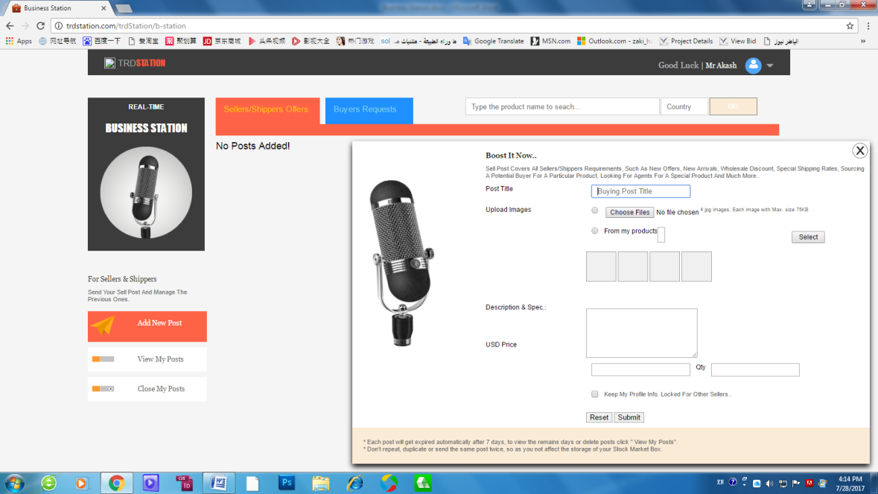

1. The post title field inatial value should be SELLING POST TITLE ( not buying).

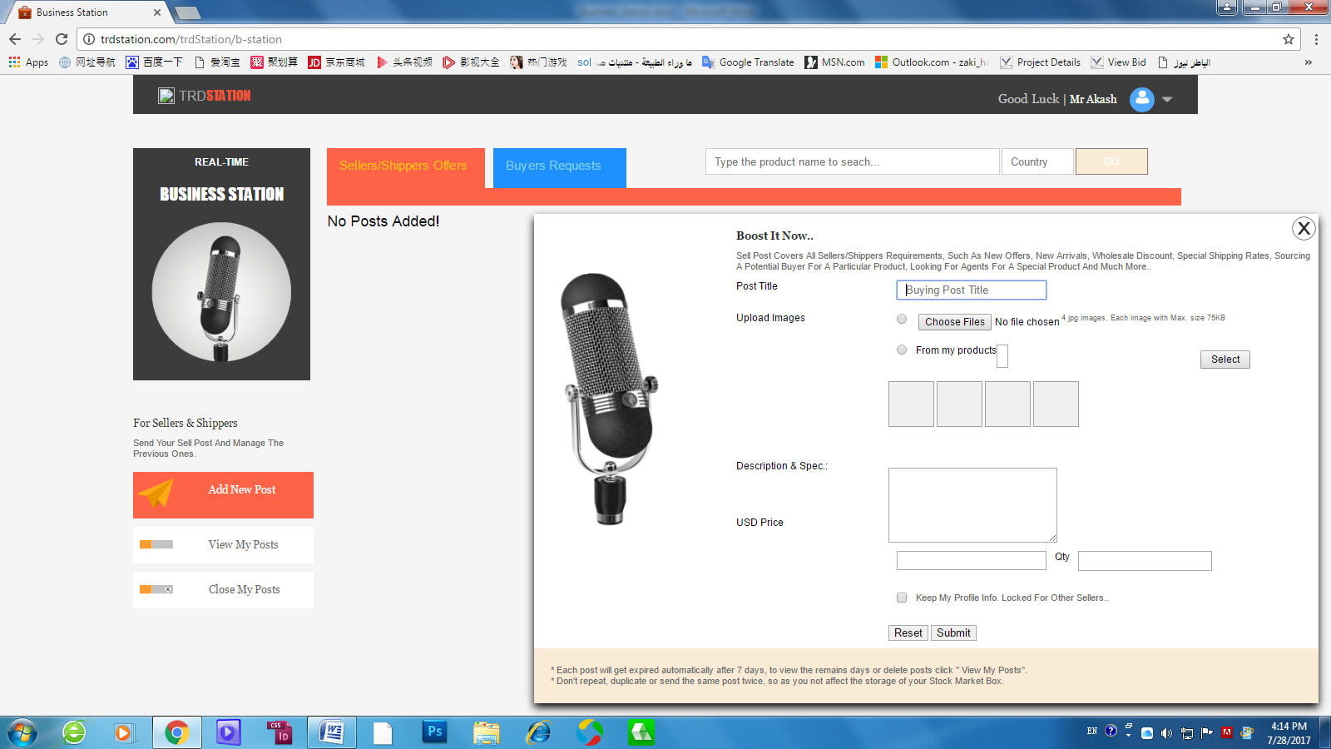

1. The Product name or No. field has error.
2. Also here to act same My Community add post, member has to checkmark on of the showing selection to start.
3. 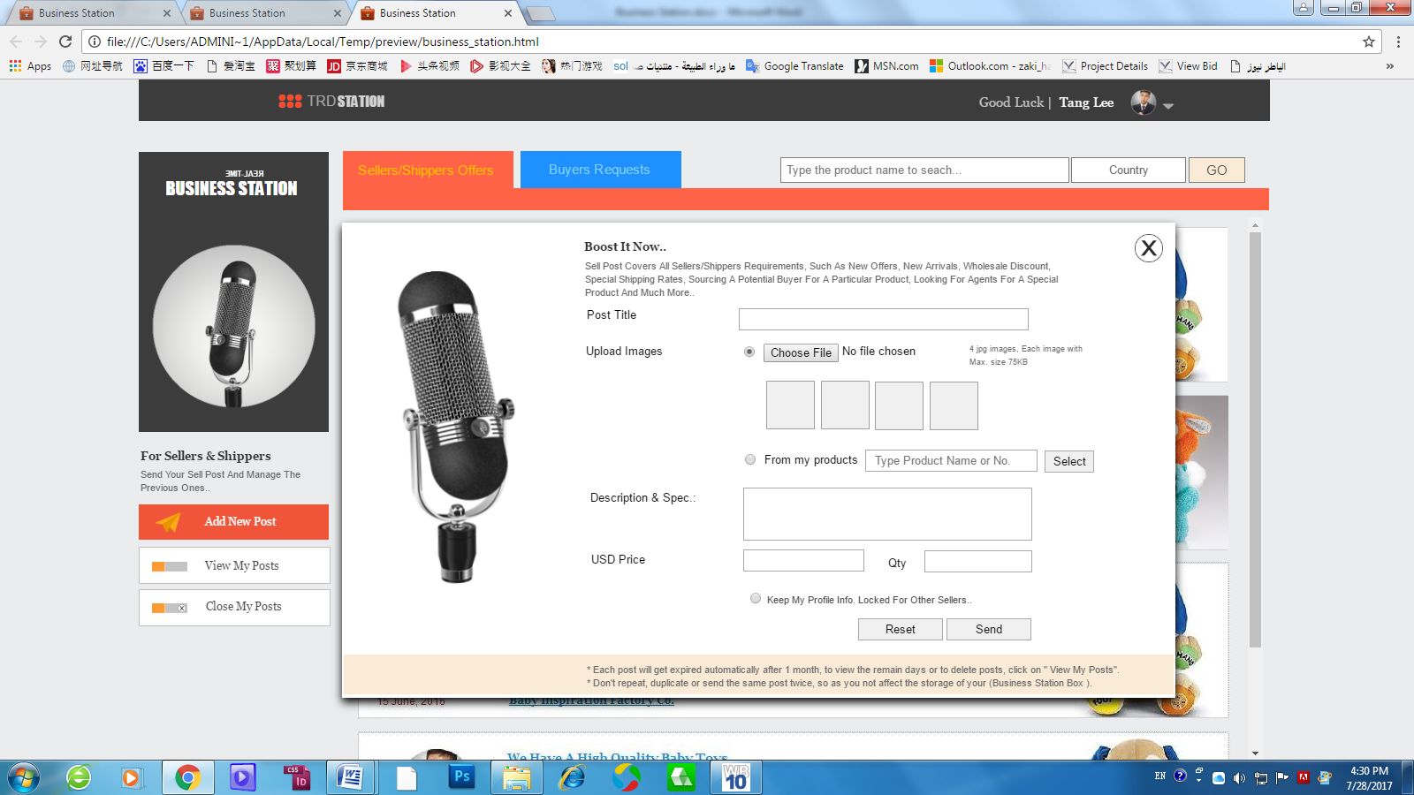 In case he just click and checkbox next to ( Choose file), it showing 4 image squares under this selection. even without he click Choose file, as showing hereunder.

**This for a 2 reasons:**

1. if the member’s 4 images are not in the same directory and he has to upload 2 images from one folder and other one from other folder and so on. so he can add the 4 image one time or click on the image square to add one by one.
2. if member need to over write one image he just can click on the image and reload.
3. In case he just click and checkbox next to ( From my products), it showing 4 image squares under this selection, even without he click Choose file, as showing hereunder.

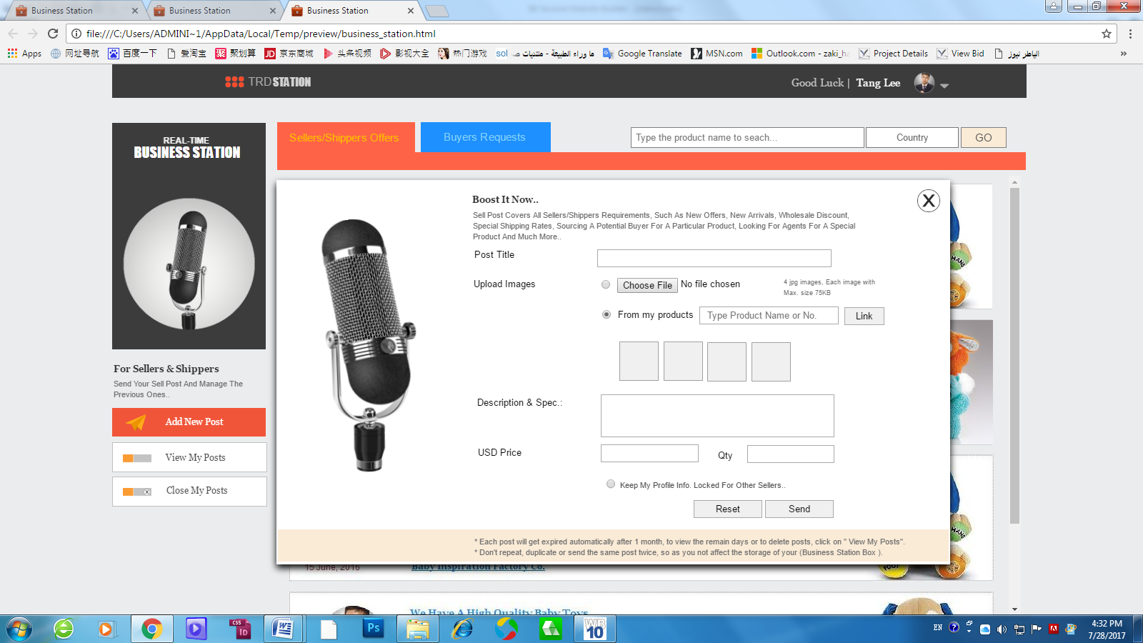

1. Change the Select button to **Link** button.
2. Change the validation in Qty field to accept **number and text**.
3. Post Title validation to be Max. 45 characters with space and Min. 6 Characters.
4. Description & spc. Field to validation to be Max. 1500 characters with space and Min. 150 Characters w space.

All the above add posts features specially in uploading images I assuming that the member can upload any dimensions as long as:

1. We have a limitation foe file size ( Each image not exceed 75 KB).
2. Crop is not required assuming that the **4 image** will be displayed in post detail layer in nice Aspect Ratio as showing in posts view the 4 squares thumbnails should not stretch or compress the images, we just can take any part of the image, SAME AS MOBILE IMAGE ALBUM, all images in different sizes but all shown in same square size thumbnail.

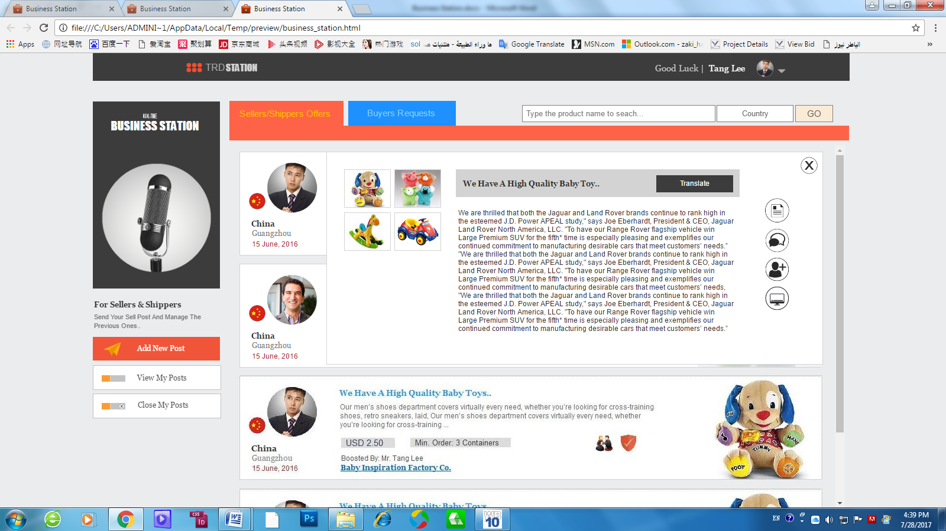

This upper part is the important because no worries when members click on images we use multi size image viewers as per implemented in my GUI.

1. **Send post:**

**after fill in the post Fields and press submit it gives this screen, please note that, this is not the way I need to information message in all the website.**

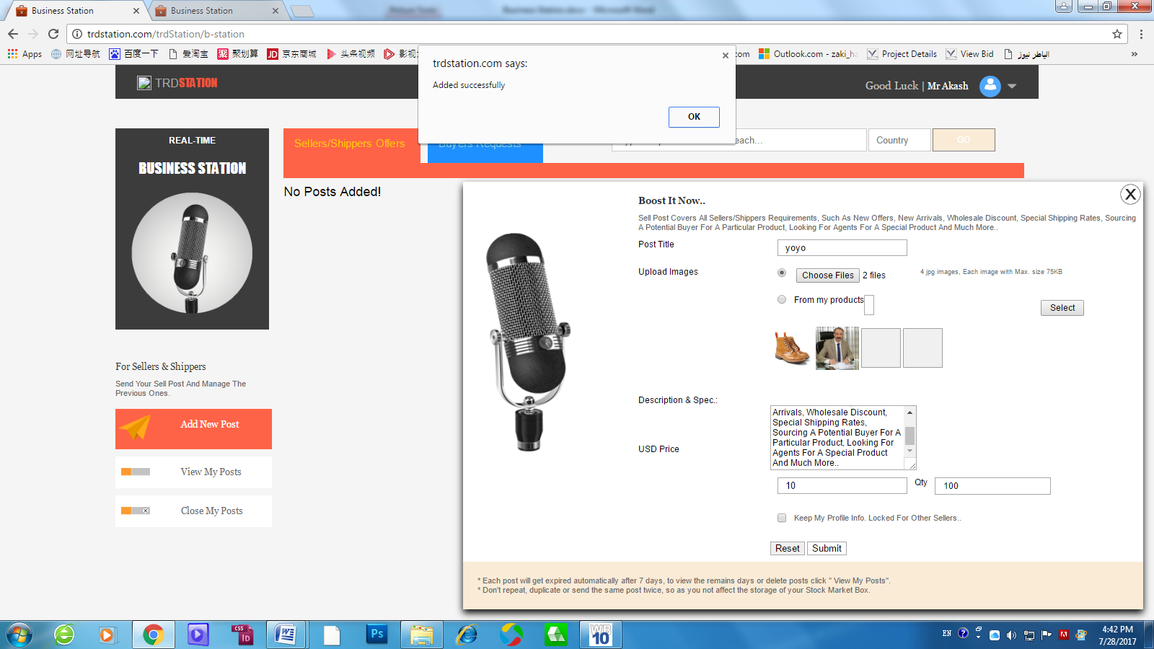**specially the boost it now layer still showing..**

**Other Critical Issue is when click on okay on the upper message it close all screen and refresh the tab and open the showing under screen which is a critical error to send the member out.**

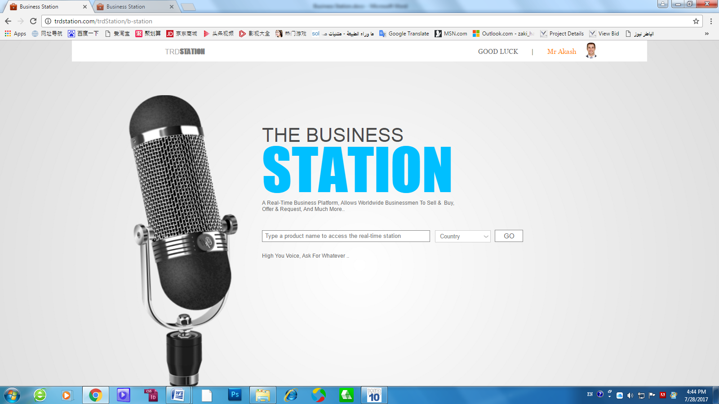

**So i explain how it should works step by step as follows:**

1. **Select the upload options showing the 4 image empty squares.**
2. **click on the file to upload it opens the images upload window to select, when member select 4, it shows the 4 selected thumbnails instead of the empty squares, In case member select just 2 images , it shows 2 images and 2 empty square so member can click on each empty image square to upload one by one or click on files to upload new add file again.**
3. **First 4 images uploaded and showing in the squares and user fill in all the form and click send, the Boost it now screen should become empty white with loading progress as showing here under.**

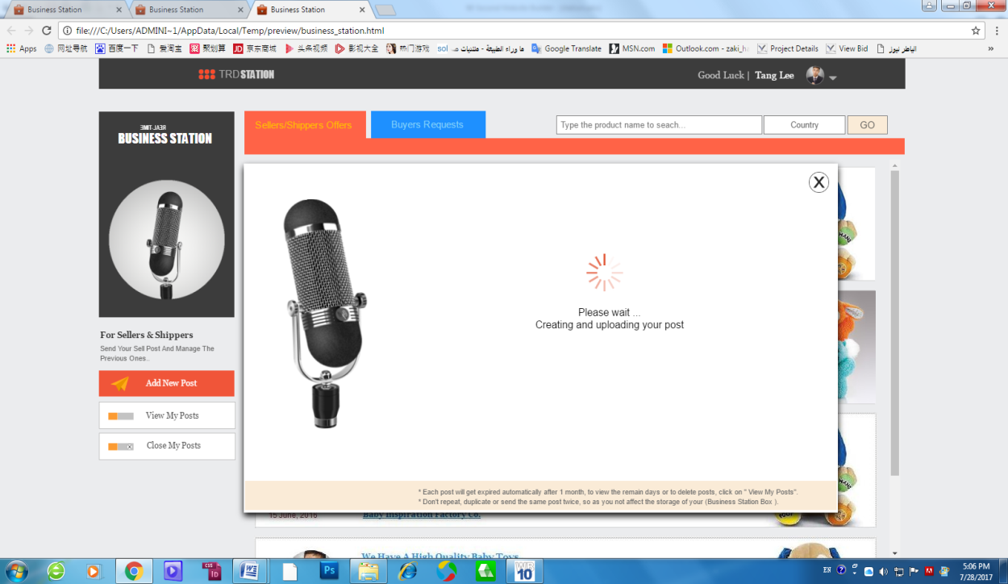

1. **While post is uploading and the progress screen is showing, our system prepare to show the post in the sellers/shippers new offer ( orange tab), when it ready or near to ready) the Boost it now screen hide the progress and showing the successful message as hereunder.**

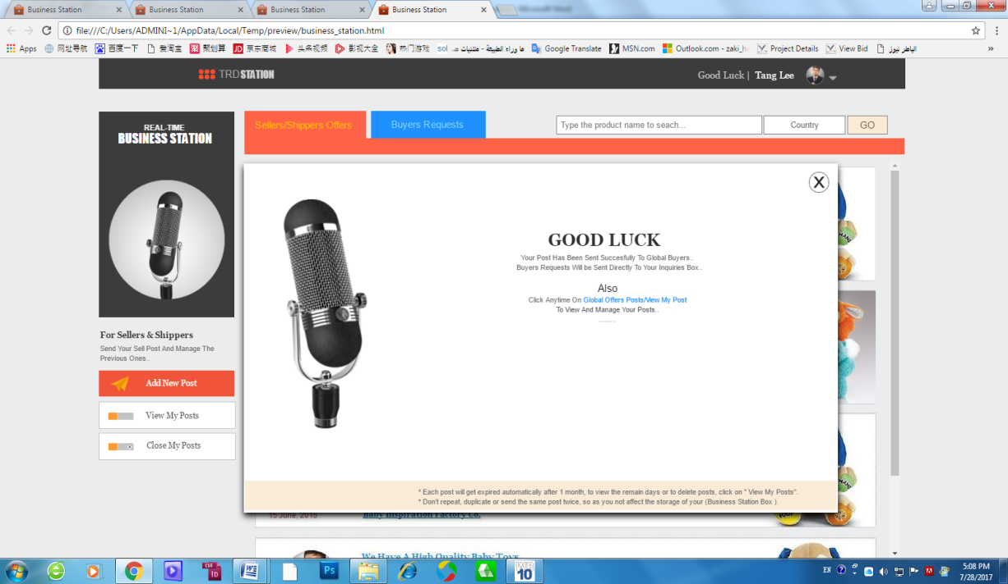

1. **This means when member close the Boost it screen he can see his post in the Seller/shipper Offers layer in real-time without refresh the page, and can click on My Posts to se his own posts including the recent send one.**

**In case refresh the page is required here so the other idea to be applied is when user close the boost it now screen, it close the Seller/shipper Offers screen and Open my posts screen then when user close My Posts and open the Seller/shipper Offers screen it shows the new post he sent.**

1. **Also please change SUBMIT button to SEND**
2. **Please note that NO limitation of how many posts members should send per day. to be confirmed.**
3. **Please note the expire period of each post to be destroyed after ( 7days) to be confirmed.**
4. **The Important part here is this “ Keep my information Locked for other Buyers” or “ Sellers”, most of the buyer or sellers worry to send offer or requests, if other buyer at the same area ( city) can see it and copy or follow or make the same order, so we have to provide users with the 100% of privacy confidential ..**

What we have to do is: if Buyer mark the checkbox “Keep my information Locked for other Buyers” so no other buyer can see his main information “ Photo + Name and company name + Country” also when buyer move mouse on the other buyer post cannot open it, and we shown “LOCK ICON” instead view icon, BUT ALL SELLERS AND SHIPPER CAN SEE HIS POST NORMAL. To be like this:

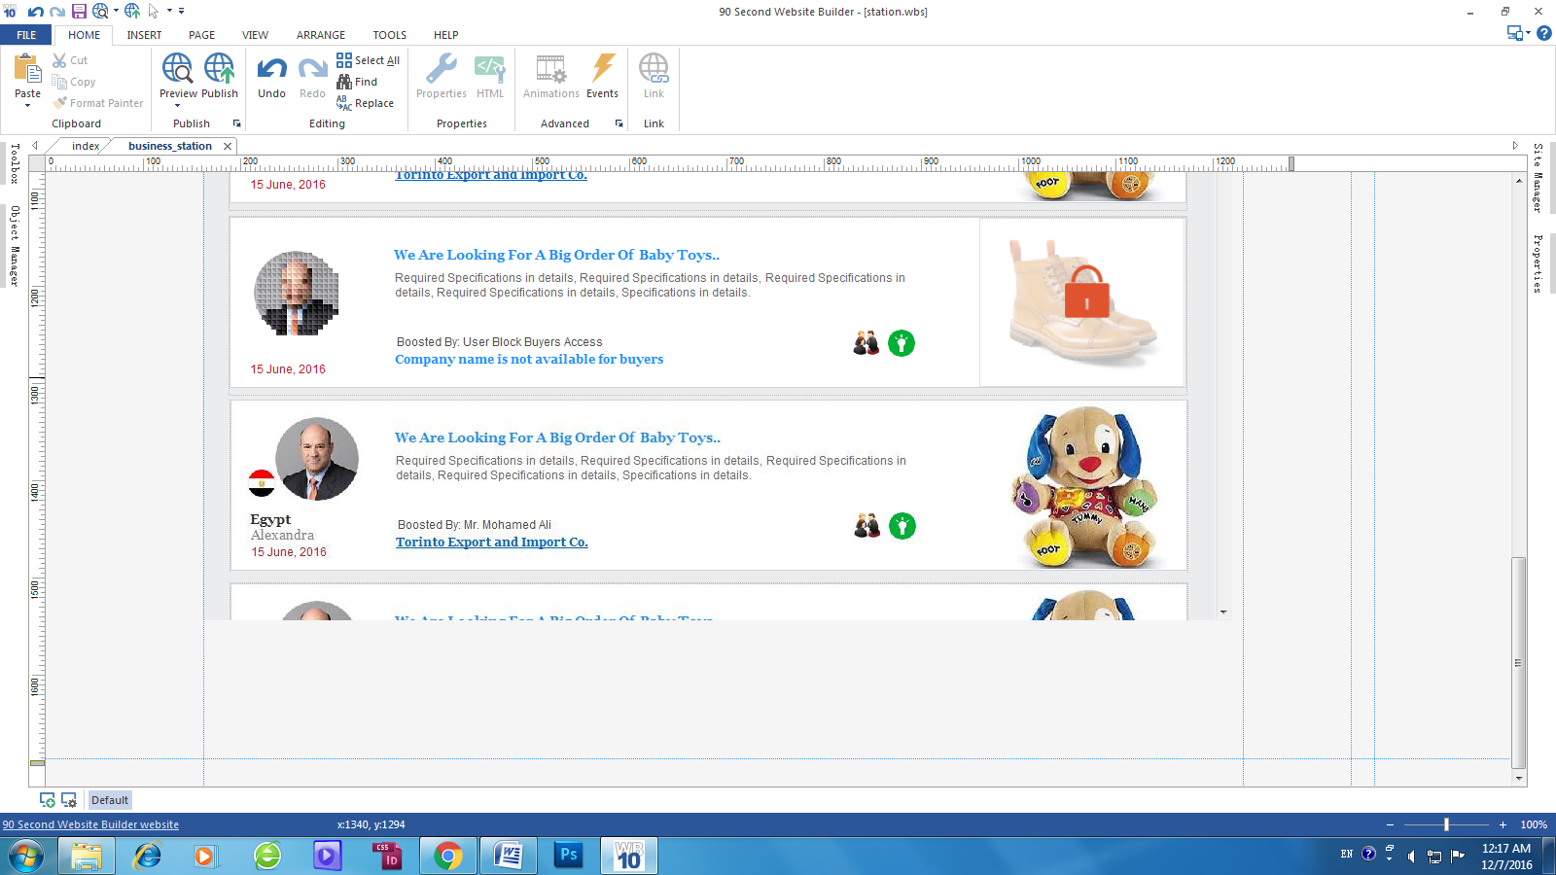

1. **This mode will not be only in business station or Stock market but in Buyer/Seller /Shipper Desksite also, because in Desksite you can view the buyer latest posts so we apply the same idea to Buyer/Seller/Shipper Desksite too.**
2. **Please note that Stock market page to be the same in technical way and even the UI way just the different is the names and colors.**